A PROJECT REPORT on

“Title of Capstone Project”
submitted in partial fulfillment of the requirements for the award of the degree of
BACHELOR OF TECHNOLOGY IN
Name of Department

Submitted By
Student Name PRN

Under the Guidance of
PROF. P. A. AWATE

Department of Electronics and Telecommunication Engineering DKTE SOCIETY'S
TEXTILE AND ENGINEERING INSTITUTE, ICHALKARANJI
An Empowered Autonomous Institute, Affiliated to Shivaji University, Kolhapur
Academic Year 2026-27

DKTE SOCIETY'S
TEXTILE AND ENGINEERING INSTITUTE, ICHALKARANJI
An Empowered Autonomous Institute, Affiliated to Shivaji University, Kolhapur
Department of Electronics and Telecommunication Engineering

CERTIFICATE
This is to certify that the project entitled
“Title of Project”
submitted by
Student Name PRN
is an authentic record of the work carried out by them under our supervision and guidance, in partial fulfillment of the requirements for the degree of Bachelor of Technology in Name of the department Engineering at DKTE Society's Textile and Engineering Institute, Ichalkaranji (An Autonomous Institute Affiliated to Shivaji University, Kolhapur) during the academic year 2026-27. The students have satisfactorily completed the project work. To the best of our knowledge and belief, the matter embodied in this report has not been submitted to any other University or Institute for the award of any degree or diploma.
Place: Ichalkaranji Date:

Prof. P. A. Awate
Guide
Prof. (Dr.) J. P. Kharat Head of Department

External Examiner Prof. (Dr.) L. S. Admuthe Director

DECLARATION

We declare that this written submission represents our ideas in our own words, and where others' ideas or words have been included, we have adequately cited and referenced the original sources. We also declare that we have adhered to all principles of academic honesty and integrity and have not misrepresented or fabricated, or falsified any idea/data/fact/source in our submission. We understand that any violation of the above will be cause for disciplinary action by the Institute and can also evoke penal action from the sources that have thus not been properly cited or from whom proper permission has not been taken when needed.

Name of the Students Signature of the students

Place: Ichalkaranji Date:

ACKNOWLEDGEMENT

We would like to express our deepest gratitude and profound appreciation to all those who have been instrumental in the successful completion of this major project. The journey of transforming an innovative idea into a functional prototype of the “Title” has been a challenging yet immensely rewarding experience, made possible by the unwavering support and guidance of numerous individuals.
First and foremost, we extend our heartfelt gratitude to our esteemed project guide, -------------, for his continuous encouragement, expert guidance, and constructive feedback throughout the project lifecycle. His deep technical insights and meticulous approach have significantly shaped the outcome of our work.
We are highly indebted to Prof. (Dr.) J. P. Kharat, Head of the Electronics and Telecommunication Engineering Department, for providing us with the necessary infrastructure, laboratory facilities, and an environment conducive to innovative learning and research.
We also extend our sincere thanks to the entire faculty and technical staff of the ETC Department at DKTE Society’s Textile and Engineering Institute, Ichalkaranji, for their indirect but invaluable support. Finally, we thank our parents and peers for their moral support, motivation, and patience during the demanding phases of this project development.
ABSTRACT
Water quality is an important factor in maintaining community health, as contaminated water can contribute to various environmental and public-health risks. Traditional water-quality monitoring often depends on periodic manual testing, which may not provide continuous information about changing water conditions. Aqua AI proposes an IoT-based water-quality monitoring and AI-driven early-warning system that provides continuous monitoring and simplified analysis of important water parameters.
The system monitors parameters such as pH, turbidity, and temperature and classifies water conditions into Safe, Moderate, and Unsafe categories using predefined threshold-based rules. A Node.js and Express.js backend processes incoming sensor data and stores observations in MongoDB. The system uses Socket.IO to provide real-time updates to a React-based web dashboard, allowing users to observe current readings and historical trends without manually refreshing the application.
To enhance the monitoring process, Aqua AI integrates Cloudflare Workers AI with the Llama 3.1 8B Instruct model to generate an indicative health-risk assessment based on available environmental data. Weather information is also incorporated to provide additional environmental context. A software-based sensor simulator is included to generate realistic sensor readings and validate the complete data-processing pipeline in the absence of physical hardware.
The proposed system demonstrates the feasibility of combining IoT, artificial intelligence, cloud services, real-time communication, and web technologies for community-level water-quality monitoring and early warning. The current implementation serves as a software and simulation-based prototype, while future development can include calibrated ESP32-based sensors, additional water-quality parameters, larger real-world datasets, and advanced machine-learning models.
Keywords: IoT, Water Quality Monitoring, Artificial Intelligence, Early Warning System, ESP32, pH, Turbidity, MongoDB, Socket.IO, Cloudflare Workers AI.

Chapter | Title | Page
1 | INTRODUCTION | 8
1.1 | Background and Context | 9
1.2 | Water Quality Monitoring and Community Health | 9
1.3 | Limitations of Conventional Manual Water Quality Monitoring | 9
1.4 | The Need for IoT and AI Integration | 10
1.5 | Organization of the Report | 11
2 | LITERATURE REVIEW | 11
2.1 | Literature Overview | 12
2.2 | Detailed Review of Core Literature | 12
2.3 | IoT-Based Water Quality Monitoring | 13
2.3.1 | Water Quality Parameters and Environmental Monitoring | 13
2.3.2 | Previous Attempts at Automated Water Quality Monitoring | 13
2.3.3 | Artificial Intelligence in Water Quality and Health Monitoring | 14
2.4 | Observations from Literature Review | 14
3 | PROBLEM STATEMENT AND OBJECTIVES | 15
3.1 | Problem Statement | 16
3.2 | Objectives of Proposed Work | 16
3.3 | Scope of the Project | 17
4 | THEORETICAL BACKGROUND | 17
4.1 | Water Quality Monitoring Fundamentals | 18
4.1.1 | Important Water Quality Parameters | 18
4.2 | Artificial Intelligence and Early-Warning Systems | 19
4.3 | Principles of IoT-Based Environmental Monitoring | 19
5 | SYSTEM ARCHITECTURE AND DESIGN | 20
5.1 | Conceptual Framework | 21
5.2 | System Block Diagram | 21
5.3 | Workflow of Proposed Work | 21
5.4 | System Design Considerations | 22
6 | HARDWARE DESIGN AND IMPLEMENTATION | 23
6.1 | Hardware Overview | 24
6.2 | Hardware Resources and Functionality | 24
6.2.1 | Microcontroller Unit (MCU) – ESP32 | 25
6.2.2 | Environmental Sensor Array | 25
6.2.3 | Power Supply and Communication Components | 26
6.3 | Sensor Data Acquisition | 27
7 | SOFTWARE AND IoT IMPLEMENTATION | 28
7.1 | Embedded Software Architecture | 29
7.2 | Control Algorithm Flowchart | 30
7.2.1 | Threshold Logic Implementation | 30
7.3 | IoT Data Integration | 31
7.4 | AI Service Implementation | 31
7.5 | Real-Time Communication Using Socket.IO | 32
7.6 | MongoDB Data Management | 33
8 | TESTING METHODOLOGY AND RESULTS | 34
8.1 | Testing Methodology | 35
8.2 | Environmental Data Simulation Results | 36
8.3 | Water Quality Classification Results | 36
8.4 | AI Analysis and System Integration Results | 36
8.5 | Real-Time Dashboard and Communication Results | 37
8.6 | Test Summary | 37
9 | CONCLUSION AND FUTURE SCOPE | 38
9.1 | Conclusion | 39
9.2 | Future Scope | 39
 | REFERENCES | 40
 | APPENDIX A: MICROCONTROLLER SOURCE CODE | 41
 | APPENDIX B: BILL OF MATERIALS (COST ESTIMATION) | 48

CHAPTER 1: INTRODUCTION

1.1 Background and Context
Water is one of the most essential resources for human life, community development, agriculture, and various domestic activities. The quality of water directly influences public health and environmental safety. Contaminated or poor-quality water can contain physical, chemical, or biological hazards that may create health risks for communities.
Traditional water-quality monitoring generally depends on collecting water samples and performing periodic measurements or laboratory analysis. Although these methods can provide reliable information, they may not provide continuous visibility into changing water conditions. A sudden change in water quality between two testing periods may therefore remain undetected.
The development of the Internet of Things (IoT) has enabled environmental parameters to be monitored continuously using sensors and connected devices. Sensor readings can be transmitted to a centralized application where they can be stored, processed, analyzed, and presented to users.
Aqua AI is proposed as an IoT-based water-quality monitoring and AI-driven early-warning system. The system focuses on monitoring important parameters such as pH, turbidity, and temperature. The collected data is processed by a backend system and classified into different water-quality conditions. The platform also incorporates artificial intelligence to provide an indicative assessment of potential health risks.
The system provides a web-based dashboard through which users can observe current measurements, water-quality status, historical information, and AI-generated analysis. The current prototype also includes a software-based simulator that represents sensor devices and generates sensor observations for testing the complete monitoring pipeline.

1.2 Water Quality Monitoring and Community Health
Water-quality monitoring is an important component of community health and environmental management. Changes in water parameters can provide indications of changes in the condition of a water source. Parameters such as pH, turbidity, and temperature are particularly useful for obtaining an initial understanding of water conditions.
pH indicates the acidic or alkaline nature of water. Significant deviations from the expected range may indicate changes in water chemistry. Turbidity represents the cloudiness of water caused by suspended particles, while temperature provides information about the thermal condition of the monitored water.
Aqua AI processes these parameters and converts the measured values into understandable water-quality categories such as Safe, Moderate, and Unsafe. This simplifies the interpretation of sensor data and allows users to identify potentially abnormal conditions more easily.
The system also introduces an AI-assisted analysis layer. The available environmental information is provided to an AI service to generate an indicative health-risk assessment. This feature is intended to support early awareness and decision-making rather than replace laboratory water testing or professional medical diagnosis.
By combining continuous monitoring, automated analysis, historical data storage, and real-time visualization, Aqua AI provides a foundation for community-level water-quality awareness and early warning.
1.3 Limitations of Conventional Manual Water Quality Monitoring
Conventional manual water-quality monitoring has several limitations when continuous observation is required.
First, manual monitoring generally depends on periodic collection and testing of water samples. Since measurements are performed at specific intervals, changes occurring between testing periods may not be immediately identified.
Second, manual monitoring requires human involvement for sample collection, measurement, recording, and analysis. This can make continuous monitoring across multiple locations difficult and resource-intensive.
Third, conventional measurement methods may produce raw numerical values that are not easily understood by users without technical knowledge. A system is therefore required to convert measurements into meaningful classifications and visual information.
Another limitation is the difficulty of maintaining a centralized historical record when observations are collected manually. Without structured digital storage, comparing current and previous observations can become difficult.
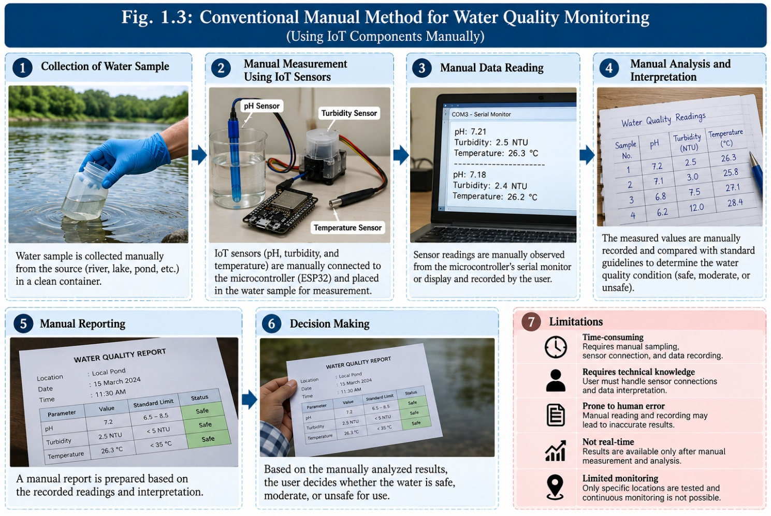
These limitations demonstrate the need for an automated system capable of collecting environmental information, processing it systematically, storing historical observations, and presenting the results through an accessible interface.
Fig. 1.3 Conventional Manual Method for Water Quality Monitoring

1.4 The Need for IoT and AI Integration
IoT technology provides an effective approach for continuously collecting environmental information. Water-quality sensors connected to an IoT-enabled device can acquire measurements and transmit them to a backend system without requiring continuous manual intervention.
Aqua AI applies this concept by providing a software architecture in which sensor observations can be received by the backend, processed, stored in MongoDB, and delivered to the frontend through Socket.IO. The real-time communication mechanism allows newly received observations to appear on the monitoring dashboard without requiring manual page refreshes.
However, collecting sensor data alone is not sufficient. Large quantities of raw measurements need to be interpreted to provide meaningful information. Aqua AI therefore uses a rule-based water-quality classification service to identify Safe, Moderate, and Unsafe conditions.
Artificial intelligence provides an additional layer of analysis. The system integrates Cloudflare Workers AI using the Llama 3.1 8B Instruct model to generate an indicative health-risk assessment from the available environmental information.
The combination of IoT, automated rule-based analysis, AI, database storage, real-time communication, and web visualization provides a more comprehensive approach to water-quality monitoring and early-warning applications.

1.5 Organization of the Report
The report is organized into nine chapters covering the development and evaluation of Aqua AI.
Chapter 1: Introduction presents the background and context of the project, the importance of water-quality monitoring, limitations of conventional monitoring methods, the need for IoT and AI integration, and the organization of the report.
Chapter 2: Literature Review discusses existing research and technologies related to water-quality monitoring, IoT-based environmental monitoring, artificial intelligence, and early-warning systems.
Chapter 3: Problem Statement and Objectives defines the identified problem, objectives of the proposed system, and scope of the project.
Chapter 4: Theoretical Background explains the fundamental concepts related to water-quality monitoring, important environmental parameters, artificial intelligence, and IoT-based monitoring systems.
Chapter 5: System Architecture and Design describes the conceptual framework, system architecture, block diagram, data flow, and design considerations of Aqua AI.
Chapter 6: Hardware Design and Implementation discusses the proposed hardware components, ESP32-based architecture, sensor array, power requirements, and sensor data acquisition. The distinction between planned physical hardware and the current simulation-based implementation is also considered.
Chapter 7: Software and IoT Implementation describes the software architecture, water-quality classification algorithm, AI integration, simulator, backend, database, real-time communication, and dashboard implementation.
Chapter 8: Testing Methodology and Results presents the testing methodology and results obtained from sensor-data simulation, water-quality classification, AI integration, real-time communication, and dashboard operation.
Chapter 9: Conclusion and Future Scope summarizes the work completed, major findings, limitations, and possible future enhancements of Aqua AI.

CHAPTER 2: LITERATURE REVIEW

2.1 Literature Overview
Water quality monitoring has become an important area of research due to the direct relationship between water conditions, environmental safety, and public health. Conventional monitoring methods generally depend on periodic sampling and laboratory analysis. Although these methods can provide accurate measurements, they may require significant time, human effort, and resources and may not provide continuous information about changes in water conditions.
Recent developments in the Internet of Things (IoT) have introduced new approaches for continuous environmental monitoring. IoT-based systems can use sensors to measure parameters such as pH, temperature, turbidity, dissolved oxygen, and other water-quality indicators. The collected data can be transmitted to a centralized server for processing, storage, and visualization.
Research has also explored the application of Artificial Intelligence (AI) and machine-learning techniques to environmental monitoring. AI can assist in identifying patterns in environmental data, predicting potential risks, and providing decision-support information. The combination of IoT and AI therefore provides an opportunity to develop monitoring systems that are not limited to data collection but can also provide automated interpretation.
The literature reviewed for this project focuses mainly on four areas: IoT-based water-quality monitoring, water-quality parameters, automated monitoring systems, and AI-assisted environmental and health-risk analysis.

2.2 Detailed Review of Core Literature
Existing research demonstrates that IoT-based environmental monitoring can improve the frequency and accessibility of water-quality observations. Sensor-based systems reduce the dependence on manual data collection by continuously acquiring measurements and transmitting them to a processing platform.
Several IoT water-monitoring approaches use microcontrollers such as Arduino and ESP32 to interface with environmental sensors. These systems commonly measure parameters including pH, temperature, turbidity, dissolved oxygen, and total dissolved solids. Sensor readings can then be transmitted through communication technologies such as Wi-Fi, GSM, Bluetooth, or other wireless protocols.
Cloud-based monitoring has also become an important component of modern environmental systems. Instead of storing measurements only on the sensing device, data can be transferred to a centralized database or cloud platform. This allows users to access historical information and monitor multiple locations through a common interface.
Another important research direction is the use of machine learning and artificial intelligence. Environmental datasets can contain relationships that are difficult to interpret using simple threshold rules. AI techniques can therefore be used to identify patterns and generate predictions or risk assessments from multiple environmental parameters.
These developments influenced the design of Aqua AI, which combines sensor-data processing, automated water-quality classification, persistent database storage, real-time communication, and AI-assisted analysis within a single monitoring platform.

2.3 IoT-Based Water Quality Monitoring
IoT-based water-quality monitoring systems consist of sensing devices, a communication layer, data-processing services, storage systems, and a user interface. Sensors collect information from the monitored water source and transmit the measurements to a processing system.
A typical IoT monitoring workflow can be represented as:
Water Source → Sensors → ESP32/IoT Device → Communication Network → Backend → Database → Analysis → Dashboard
The use of IoT enables monitoring to move from periodic manual measurements toward continuous or frequent observation. It also allows multiple sensing devices to be connected to a centralized platform.
Aqua AI follows a similar architectural approach. The current prototype uses a software simulator to represent the sensor device and generate readings. The backend receives these observations, processes them, stores them in MongoDB, and sends real-time updates to the web dashboard through Socket.IO.
The architecture can later be extended by replacing the simulator with physical ESP32-based sensor nodes.

2.3.1 Water Quality Parameters and Environmental Monitoring
Water quality is influenced by several physical and chemical parameters. Different parameters provide different information about the condition of a water source.
pH
pH represents the acidity or alkalinity of water. Significant changes in pH can indicate changes in water chemistry and may affect the suitability of water for different applications. Aqua AI uses pH as one of the primary parameters in its water-quality classification.
Turbidity
Turbidity indicates the presence of suspended particles that make water appear cloudy. Increased turbidity can indicate changes in water conditions and is therefore useful for monitoring. Aqua AI uses turbidity values measured in NTU as part of its classification logic.
Temperature
Water temperature can influence chemical and biological processes within a water system. It is therefore useful as an environmental monitoring parameter. Aqua AI records temperature along with pH and turbidity to provide additional context for water-quality assessment.
Combined Environmental Monitoring
Monitoring multiple parameters provides more information than relying on a single measurement. Aqua AI combines pH, turbidity, and temperature to determine the overall water-quality classification.
The implemented classification rules identify water as Unsafe when pH is below 6.5, pH is above 8.5, turbidity exceeds 10 NTU, or temperature exceeds 35°C. Water is classified as Moderate when turbidity exceeds 5 NTU but does not meet an Unsafe condition. Otherwise, the system classifies the condition as Safe.

2.3.2 Previous Attempts at Automated Water Quality Monitoring
Previous automated water-quality monitoring systems have demonstrated the feasibility of combining sensors with microcontrollers and communication technologies. Many systems use embedded controllers to acquire measurements and transmit them to remote monitoring platforms.
Some systems focus primarily on collecting and displaying sensor measurements, while others provide automated alerts when a measured parameter exceeds a predefined threshold. Cloud-based systems further enable users to access measurements remotely and maintain historical records.
However, automated monitoring systems can differ considerably in their scope. Some focus on individual water-quality parameters, while others combine multiple parameters and provide an overall classification. More advanced systems incorporate data analytics or machine-learning techniques to identify patterns and support prediction.
Aqua AI builds upon these concepts by combining automated classification, persistent data storage, real-time visualization, and AI-assisted analysis. The project also uses a software simulator to validate the complete data pipeline before physical sensor deployment.

2.3.3 Artificial Intelligence in Water Quality and Health Monitoring
Artificial intelligence has increasingly been applied to environmental monitoring because of its ability to process large quantities of data and identify relationships between multiple variables.
Machine-learning approaches can be used for tasks such as water-quality prediction, anomaly detection, classification, and forecasting. By analyzing historical environmental measurements, trained models can potentially identify patterns that are difficult to capture through fixed threshold rules.
AI can also provide a natural-language interpretation of environmental information. Instead of presenting users only with numerical sensor readings, an AI system can generate an explanatory assessment based on the available parameters.
Aqua AI incorporates this concept through Cloudflare Workers AI and the Llama 3.1 8B Instruct model. The backend sends relevant environmental information to the AI service, which generates an indicative health-risk assessment.
The AI component is designed as an early-warning and decision-support mechanism rather than a clinical diagnostic system. Its output should therefore be interpreted together with sensor measurements and, where required, laboratory testing and professional assessment.

2.4 Observations from Literature Review
The literature review provides several observations that influenced the development of Aqua AI:
- Continuous monitoring: IoT systems can provide more frequent observations than conventional periodic monitoring.
- Multi-parameter analysis: Combining pH, turbidity, and temperature provides a broader view of water conditions than monitoring a single parameter.
- Automated classification: Rule-based classification can convert raw sensor measurements into understandable water-quality categories.
- Centralized data storage: Database integration allows sensor observations to be stored and used for historical analysis.
- Real-time visualization: Web-based dashboards can make environmental information accessible to users and display newly received measurements.
- AI-assisted analysis: Artificial intelligence can provide an additional interpretation layer and support early identification of potential risks.
- Scalable architecture: Separating sensor acquisition, backend processing, database storage, AI services, and frontend visualization makes the system easier to extend.

- Need for real-world validation: Simulation is useful for validating the software pipeline, but physical sensors and real-world datasets are required to evaluate measurement accuracy and long-term performance.
Based on these observations, Aqua AI combines IoT-oriented data acquisition, rule-based water-quality assessment, AI-assisted analysis, database storage, real-time communication, and web-based visualization into a unified monitoring platform.

CHAPTER 3: PROBLEM STATEMENT AND OBJECTIVES

3.1 Problem Statement
Water quality is an important factor in maintaining community health and environmental safety. However, conventional water-quality monitoring methods often depend on periodic manual measurements or laboratory testing. Such methods may require considerable human effort and may not provide continuous information about changes in water conditions.
Another challenge is that water-quality parameters such as pH, turbidity, and temperature are generally obtained as individual numerical values. Without automated processing and visualization, it can be difficult for non-technical users to understand whether the observed conditions indicate a potential problem.
There is also a need for timely identification of abnormal water conditions. A monitoring system that can continuously receive sensor observations, classify water quality, store historical data, and provide real-time information can improve the availability and accessibility of water-quality information.
Therefore, the problem addressed by this project is the development of a real-time water-quality monitoring and AI-assisted early-warning system capable of processing environmental observations and presenting meaningful information to users.
Aqua AI addresses this problem by combining IoT-oriented sensor data acquisition, automated water-quality classification, database storage, AI-assisted health-risk analysis, real-time communication, and a web-based dashboard. The current prototype uses a software simulator to generate sensor observations, providing a basis for validating the complete software pipeline before physical sensor deployment.

3.2 Objectives of Proposed Work
The main objective of Aqua AI is to develop an integrated platform for monitoring water-quality conditions and providing an AI-assisted early-warning mechanism.
The specific objectives are:
- To develop a water-quality monitoring system capable of receiving measurements such as pH, turbidity, and temperature.
- To implement automated water-quality classification using predefined threshold conditions to categorize water as Safe, Moderate, or Unsafe.
- To develop a backend processing system using Node.js and Express.js for receiving, processing, and managing sensor observations.
- To store sensor observations systematically using MongoDB for maintaining historical monitoring data.
- To integrate artificial intelligence using Cloudflare Workers AI and the Llama 3.1 8B Instruct model for generating indicative health-risk assessments.
- To implement real-time communication using Socket.IO so that newly received sensor observations can be reflected on the dashboard without manual page refreshes.
- To develop an interactive web dashboard using React.js and related frontend technologies for displaying sensor measurements, water-quality status, historical information, and AI analysis.
- To develop a sensor-data simulator that represents an IoT device and generates observations for testing the system in the absence of physical hardware.
- To establish a scalable architecture that can be extended in the future with physical ESP32-based sensors and additional environmental parameters.
- To provide an early-warning mechanism that can help users identify potentially abnormal water conditions and encourage further investigation or testing.

3.3 Scope of the Project
The scope of Aqua AI covers the development of a software-based platform for water-quality monitoring and AI-assisted early warning.
The system currently focuses on pH, turbidity, and temperature as the primary monitored parameters. Sensor observations are generated through a simulator and transmitted to the backend through API requests. The backend processes the observations and applies predefined water-quality classification rules.
The project includes MongoDB-based data storage for maintaining sensor observations and supporting historical monitoring. A React-based web dashboard provides users with access to current and historical information. Socket.IO is used to provide real-time updates between the backend and frontend.
The scope also includes integration with Cloudflare Workers AI for generating an indicative health-risk assessment from available environmental information. Weather information can additionally be incorporated to provide environmental context.
The current project does not include laboratory validation of water samples, clinical disease diagnosis, or a trained custom machine-learning model for disease prediction. Physical ESP32 and water-quality sensor deployment is also not part of the currently validated prototype; the simulator is used to represent the sensor layer.
Future extensions may include:
- Integration of physical ESP32-based sensor nodes.
- Additional sensors such as dissolved oxygen, TDS, conductivity, and water-level sensors.
- Collection of large-scale real-world water-quality datasets.
- Development and training of custom machine-learning models.
- Mobile application support.
- Location-based monitoring using GIS.
- Automated SMS, email, or push notifications.
- Deployment across multiple communities and water sources.
- Long-term predictive analysis of water-quality trends.

CHAPTER 4: THEORETICAL BACKGROUND

4.1 Water Quality Monitoring Fundamentals
Water quality refers to the physical, chemical, and biological characteristics of water that determine its suitability for a particular use. Continuous monitoring of water-quality parameters helps identify changes in water conditions and provides useful information for environmental and public-health management.
Aqua AI focuses on three primary parameters: pH, turbidity, and temperature. These parameters are collected as sensor observations and processed by the backend to determine the overall water-quality condition.
The system uses a rule-based classification approach in which measured values are compared against predefined threshold conditions. Based on these conditions, the system categorizes the observed water condition as Safe, Moderate, or Unsafe.
The theoretical monitoring process can be represented as:
Sensor Data → Parameter Processing → Threshold Evaluation → Water Quality Classification → AI Analysis → Dashboard
This approach provides a simple and understandable method for converting raw environmental measurements into useful monitoring information.

4.1.1 Important Water Quality Parameters
pH
pH represents the acidic or alkaline nature of water. It is an important parameter because significant changes in pH can indicate changes in water chemistry.
In Aqua AI, pH is continuously considered during water-quality classification. According to the implemented classification logic, a pH value below 6.5 or above 8.5 results in an Unsafe classification.
Turbidity
Turbidity represents the cloudiness of water caused by suspended particles. It is measured in NTU (Nephelometric Turbidity Units).
Aqua AI uses turbidity as an important indicator of water condition. A turbidity value greater than 10 NTU results in an Unsafe classification. A value greater than 5 NTU but not exceeding the Unsafe threshold results in a Moderate classification.
Temperature
Temperature represents the thermal condition of the monitored water. Changes in temperature can provide additional environmental information and can influence biological and chemical processes in water.
In Aqua AI, a temperature value greater than 35°C is considered an Unsafe condition according to the implemented water-quality rules.
Combined Parameter Analysis
Instead of evaluating only one parameter, Aqua AI combines pH, turbidity, and temperature to determine the overall condition.

The classification logic can be summarized as:
Condition | Water Quality
pH < 6.5 or pH > 8.5 | Unsafe
Turbidity > 10 NTU | Unsafe
Temperature > 35°C | Unsafe
Turbidity > 5 NTU | Moderate
None of the above conditions | Safe
This rule-based approach provides a deterministic and explainable method for initial water-quality assessment.

4.2 Artificial Intelligence and Early-Warning Systems
Artificial Intelligence (AI) refers to computational techniques that enable software systems to analyze information and generate outputs that support decision-making. In environmental monitoring, AI can be used to identify patterns, summarize observations, detect potential anomalies, and provide predictive or risk-oriented information.
An early-warning system is designed to provide information about potentially abnormal conditions before they develop into more serious situations. Such systems are particularly useful when monitoring environmental conditions that can change over time.
Aqua AI incorporates AI as an additional analytical layer over the sensor measurements. The system sends relevant environmental information to Cloudflare Workers AI, using the Llama 3.1 8B Instruct model. The AI service generates an indicative health-risk assessment based on the available sensor information.
The AI output is intended to support awareness and early investigation. It does not replace laboratory water-quality analysis, professional environmental assessment, or medical diagnosis.
The theoretical flow of the AI component is:
Sensor Measurements → Backend Processing → AI Prompt → AI Model → Health-Risk Assessment → Dashboard

4.3 Principles of IoT-Based Environmental Monitoring
The Internet of Things (IoT) refers to the connection of physical devices, sensors, communication systems, and software platforms for collecting and exchanging data.
An IoT-based environmental monitoring system generally consists of the following layers:
Sensing Layer
The sensing layer contains sensors that collect measurements from the physical environment. For Aqua AI, the primary measurements are pH, turbidity, and temperature.
Processing Layer
The processing layer receives sensor observations and performs calculations or classification. In Aqua AI, the Node.js and Express.js backend performs this role.
Communication Layer
The communication layer transfers sensor observations between the monitoring device and backend services. The current prototype uses HTTP-based API communication for sensor-data submission.
Storage Layer
The storage layer maintains collected observations for future access and analysis. Aqua AI uses MongoDB through Mongoose for storing sensor data.
Application Layer
The application layer presents processed information to users. Aqua AI uses a React.js web dashboard to display sensor measurements, water-quality classifications, and AI-generated analysis.
Real-Time Communication
Real-time communication allows newly received sensor observations to be delivered to connected users immediately. Aqua AI uses Socket.IO to broadcast updated sensor information from the backend to the frontend.
The overall theoretical architecture can therefore be represented as:
Environmental Source → Sensors/Simulator → Communication → Express Backend → MongoDB + AI Service → Socket.IO → React Dashboard
This layered architecture separates data acquisition, processing, storage, AI analysis, and visualization, making the system easier to maintain and extend.

CHAPTER 5: SYSTEM ARCHITECTURE AND DESIGN

5.1 Conceptual Framework
Aqua AI is designed as a real-time water-quality monitoring and AI-assisted early-warning system. The conceptual framework consists of five major stages: data acquisition, data transmission, backend processing, AI-based analysis, and visualization.
In the current prototype, sensor observations are generated using a software-based simulator. The simulator represents an IoT sensing device and generates values for pH, turbidity, temperature, battery level, device identification, and location information. These observations are transmitted to the backend through HTTP requests.
The backend receives the incoming data and validates and processes the measurements. The water-quality service applies predefined threshold conditions to classify the water condition as Safe, Moderate, or Unsafe. The processed observation is then stored in MongoDB.
The system additionally sends relevant sensor information to the AI service for generating an indicative health-risk assessment. The processed information is transmitted to the frontend using Socket.IO, allowing the dashboard to update in real time.
The conceptual flow of the system is:
Sensor/Simulator → REST API → Backend Processing → Water Quality Classification → MongoDB + AI Analysis → Socket.IO → React Dashboard
The architecture is designed so that the current simulator can later be replaced by physical ESP32-based sensor hardware without requiring major changes to the frontend or overall backend architecture.
5.2 System Block Diagram
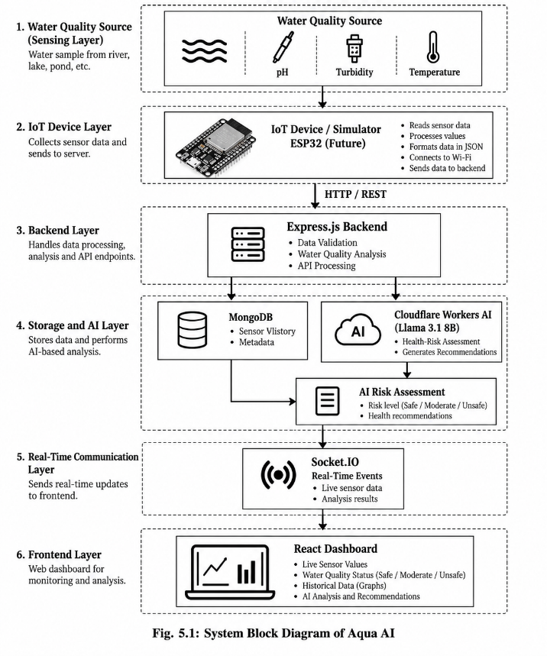
The major components of Aqua AI and their relationships are represented below.

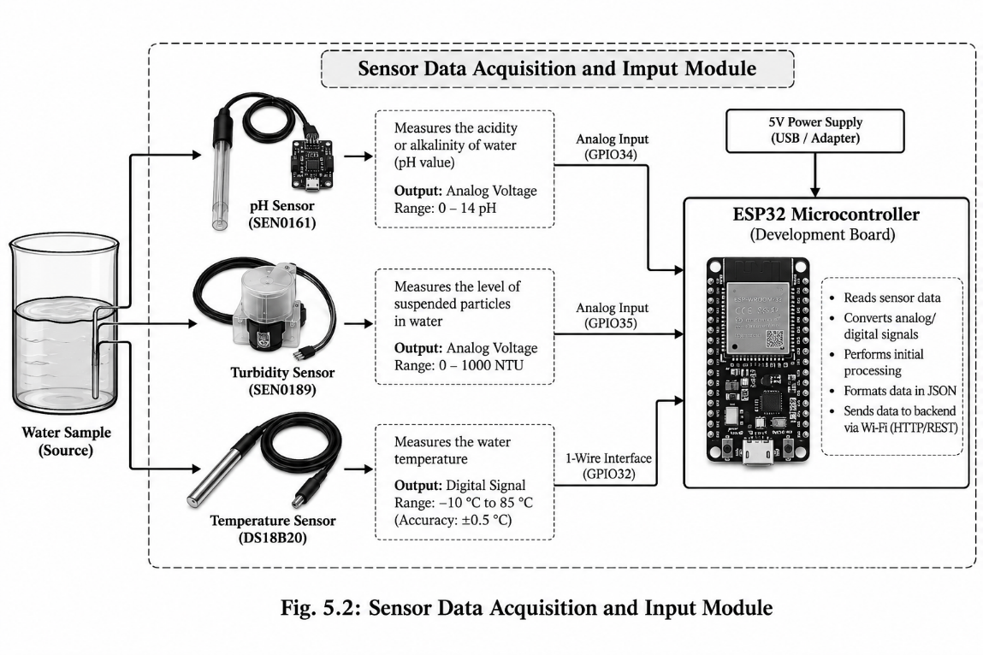
The architecture separates data collection, processing, storage, AI analysis, and presentation. This separation improves maintainability and allows individual components to be extended independently.

5.3 Workflow of Proposed Work
The operational workflow of Aqua AI consists of the following steps:
Step 1: Sensor Data Generation
The monitoring layer generates observations containing parameters such as pH, turbidity, and temperature. In the current implementation, these observations are generated by the simulator.
Step 2: Data Transmission
The simulator sends the generated observation to the Express.js backend using an HTTP POST request. In a future physical implementation, an ESP32-based device can transmit the sensor readings through the same communication layer.
Step 3: Backend Data Processing
The backend receives the observation and processes the submitted values. Sensor information such as device ID, location, battery level, pH, turbidity, and temperature is handled by the backend services.
Step 4: Water Quality Classification
The water-quality service evaluates the received parameters using predefined threshold rules.
The classification process follows:
*The Safe classification applies when none of the Unsafe or Moderate conditions are satisfied and the temperature is within the defined threshold.
Step 5: Database Storage
After processing, the sensor observation is stored in MongoDB. This provides a persistent record that can be used for displaying historical observations and analyzing trends.
Step 6: AI Analysis
The backend provides relevant sensor information to the Cloudflare Workers AI service. The Llama 3.1 8B Instruct model generates an indicative health-risk assessment based on the available environmental information.
Step 7: Real-Time Broadcasting
The backend broadcasts updated sensor information through Socket.IO. Connected frontend clients receive the event without needing to refresh the webpage.
Step 8: Dashboard Visualization
The React frontend displays the latest measurements, water-quality status, historical information, and AI-generated analysis in a user-friendly dashboard.
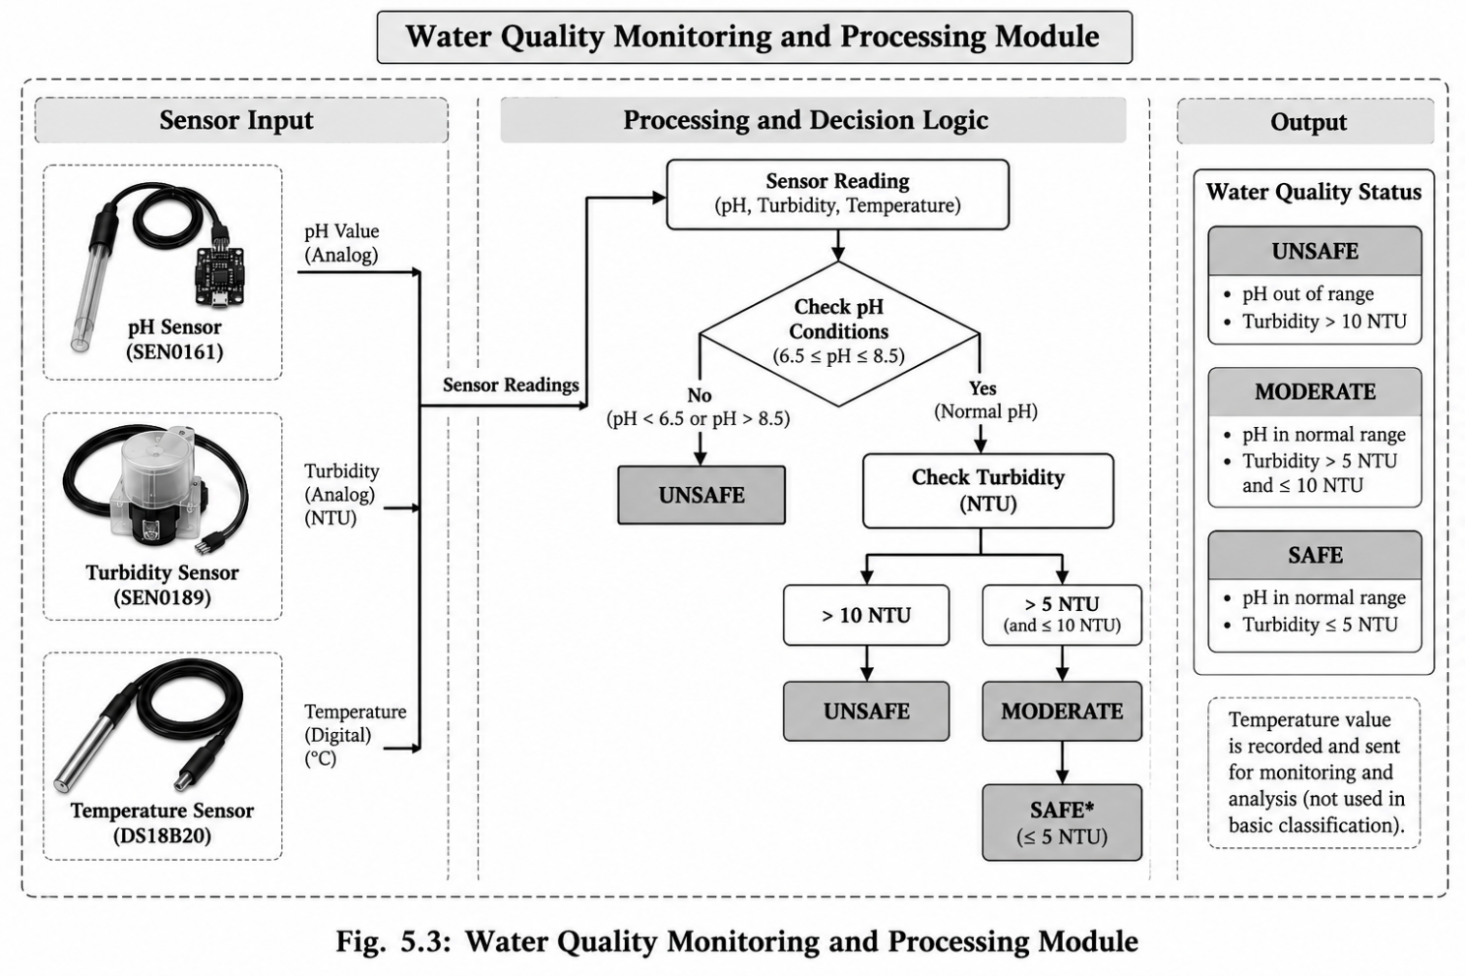

5.4 System Design Considerations
Several design considerations were followed during the development of Aqua AI.
Modularity
The system is divided into independent components such as the simulator, backend services, database, AI service, real-time communication layer, and frontend. This allows individual components to be modified or replaced without redesigning the entire system.
Real-Time Operation
Water-quality conditions can change over time. Therefore, the system uses Socket.IO to provide real-time updates from the backend to connected dashboard users.
Data Persistence
Sensor observations are stored in MongoDB rather than being maintained only in memory. This enables historical observations to remain available for later visualization and analysis.
Explainable Classification
The initial water-quality classification is based on explicit threshold rules. This makes the Safe, Moderate, and Unsafe classifications understandable and traceable to the measured parameters.
AI Integration
AI is implemented as an additional analysis layer rather than the sole mechanism for determining water quality. The deterministic classification remains independent of the AI-generated assessment.
Scalability
The architecture allows the simulator to be replaced by physical IoT devices in the future. Additional sensors, devices, locations, and analytical services can also be incorporated without fundamentally changing the frontend architecture.
Reliability and External Dependencies
The system depends on external services such as MongoDB Atlas and Cloudflare Workers AI. Internet connectivity is therefore required for the complete system operation. The current prototype also depends on simulated sensor data because physical hardware has not yet been integrated.
Security and Configuration
Sensitive configuration values such as database credentials, JWT secrets, and external API credentials are maintained through environment variables rather than being directly embedded into the application source code.
Overall, the proposed architecture provides a structured foundation for combining IoT-oriented environmental monitoring, automated water-quality assessment, AI-assisted analysis, persistent data storage, and real-time visualization within Aqua AI.

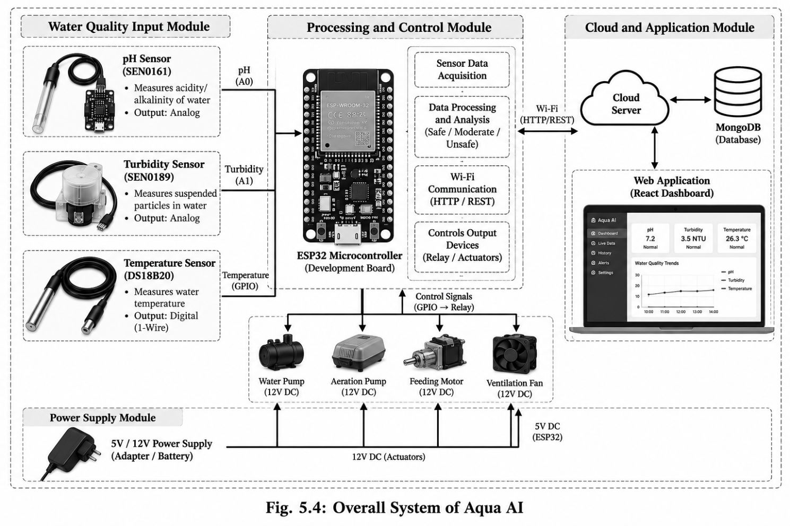
CHAPTER 6: HARDWARE DESIGN AND IMPLEMENTATION

6.1 Hardware Overview
Aqua AI is designed as an IoT-oriented water-quality monitoring system in which environmental sensors can be connected to a microcontroller and used to collect water-quality observations. The proposed hardware layer is responsible for acquiring parameters such as pH, turbidity, and temperature and transmitting the collected measurements to the software platform.
The ESP32 is considered the primary microcontroller for the proposed physical implementation because it provides processing capability, GPIO interfaces, and wireless connectivity suitable for IoT applications.
However, the current Aqua AI prototype has not yet integrated physical sensor hardware. The hardware layer is represented by a software-based simulator that generates sensor observations and sends them to the backend. Therefore, the hardware components described in this chapter represent the proposed physical implementation and future extension of the current prototype.

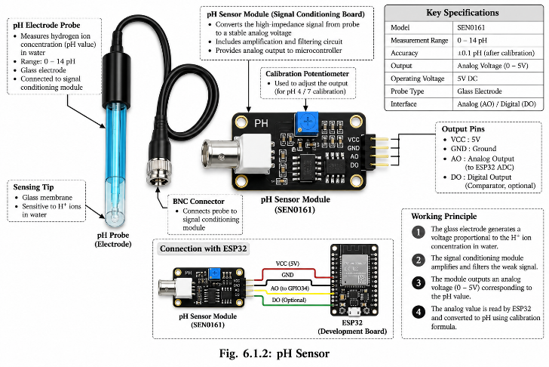
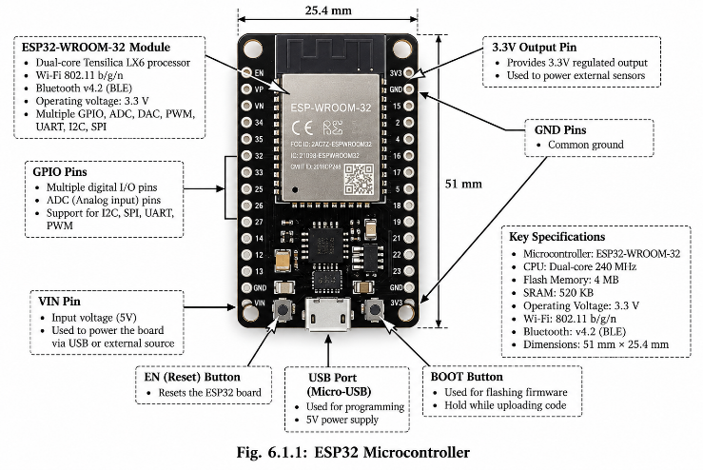

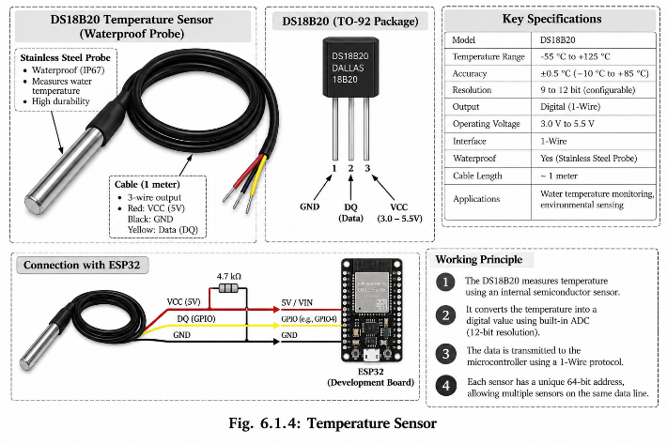
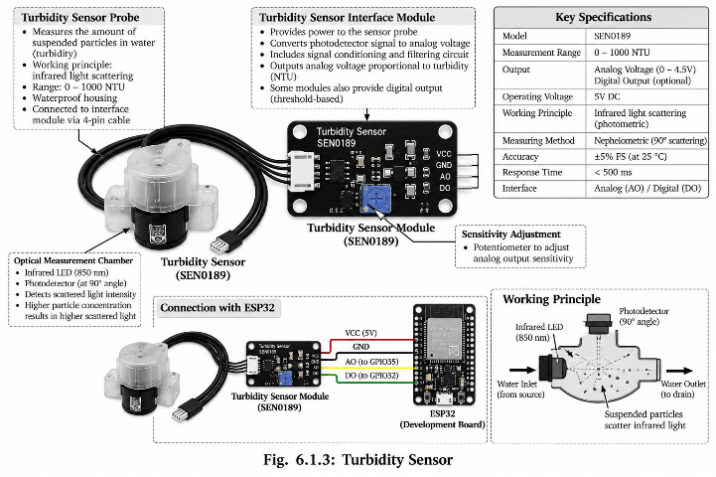

6.2 Hardware Resources and Functionality
The proposed hardware system consists of a microcontroller, environmental sensors, communication facilities, and a suitable power supply.
Table 6.1: Proposed Hardware Components
Component | Function
ESP32 | Main microcontroller and IoT communication unit
pH Sensor | Measures the acidity or alkalinity of water
Turbidity Sensor | Measures the cloudiness or suspended particles in water
Temperature Sensor | Measures water temperature
Power Supply | Provides electrical power to the monitoring unit
Connecting Wires | Provides electrical connections between components
Wi-Fi | Transfers sensor observations to the backend
The hardware architecture is designed to collect environmental measurements and transfer them to the software platform for further processing and visualization.

6.2.1 Microcontroller Unit (MCU) – ESP32
The ESP32 is proposed as the central processing unit of the physical Aqua AI monitoring device. It is responsible for acquiring sensor measurements, performing basic processing, and transmitting the observations to the backend server.
The ESP32 provides multiple GPIO interfaces that can be used to connect environmental sensors. Its built-in wireless connectivity also makes it suitable for IoT applications where sensor data needs to be transmitted to a remote backend.
The expected operation of the ESP32-based monitoring unit is:
- Initialize the connected sensors.
- Establish a Wi-Fi connection.
- Read pH, turbidity, and temperature values.
- Perform basic validation of the readings.
- Prepare the sensor data in a suitable format.
- Send the data to the Aqua AI backend through an API.
- Repeat the process at a predefined interval.
In the current implementation, these activities are represented by the software simulator, which generates sensor readings and sends them to the same backend API.

6.2.2 Environmental Sensor Array
The proposed environmental sensor array consists of sensors for measuring pH, turbidity, and temperature. These parameters form the primary input for the Aqua AI water-quality classification system.
pH Sensor
The pH sensor is used to measure the acidity or alkalinity of the monitored water. The sensor produces a measurement that can be converted into a numerical pH value and transmitted to the ESP32.
The backend uses the pH value as one of the primary conditions for determining the water-quality status.
Turbidity Sensor
The turbidity sensor measures the amount of suspended material present in water and provides a turbidity measurement generally represented in NTU.
The measured value is transmitted to the processing system and used by the water-quality classification service. Turbidity above the configured thresholds can result in Moderate or Unsafe classification.
Temperature Sensor
The temperature sensor measures the temperature of the monitored water. The measurement provides additional environmental information and is included in the sensor data transmitted to the backend.
According to the current classification logic, a temperature above 35°C is considered an Unsafe condition.
Sensor Data Structure
The collected information can be represented conceptually as:
Device ID
Location
│
├── pH
├── Turbidity
├── Temperature
└── Battery Status
These values form the basic observation that is transferred to the Aqua AI backend.

6.2.3 Power Supply and Communication Components
The physical monitoring unit requires a stable power source capable of supplying the ESP32 and connected sensors.
The ESP32 communicates with the backend using a wireless network. The proposed communication process is:
Environmental Sensors
│
▼
ESP32
│
Wi-Fi
│
▼
Aqua AI Backend API
The wireless connection enables the monitoring device to transmit sensor observations without requiring a direct wired connection to the backend server.
The communication layer also allows multiple monitoring devices to be incorporated in future implementations. Each device can be assigned a unique device identifier so that observations can be associated with their corresponding monitoring location.

6.3 Sensor Data Acquisition
Sensor data acquisition is the first stage of the physical monitoring process. The ESP32 periodically reads values from the connected environmental sensors.
The general acquisition procedure is:
Start
│
▼
Initialize ESP32
│
▼
Initialize Sensors
│
▼
Connect to Wi-Fi
│
▼
Read pH
│
▼
Read Turbidity
│
▼
Read Temperature
│
▼
Validate Readings
│
▼
Create Sensor Data
│
▼
Send Data to Backend
│
▼
Wait for Next Reading
│
└──────────────► Repeat
The backend subsequently processes the received values and applies the water-quality classification rules.
In the current prototype, the same data-acquisition concept is implemented through the simulator rather than physical sensors. The simulator generates representative observations and submits them to the backend, allowing the API, database, classification service, AI service, Socket.IO communication, and dashboard to be tested before physical hardware integration.
The hardware design therefore provides a clear path for future deployment: the simulated sensor-data source can be replaced by an ESP32 and physical water-quality sensors while retaining the existing backend and frontend architecture.
CHAPTER 7: SOFTWARE AND IoT IMPLEMENTATION
7.1 Embedded Software Architecture
The software architecture of Aqua AI is designed to collect, process, store, analyze, and visualize water-quality observations. The system follows a modular architecture consisting of the sensor-data generation layer, backend API, water-quality analysis service, database, AI service, real-time communication layer, and frontend dashboard.
The current prototype uses a software simulator to represent the IoT sensing device. The simulator generates sensor observations and sends them to the backend using HTTP requests. In the proposed physical implementation, the simulator can be replaced by an ESP32 connected to water-quality sensors.
The major software components are:
- Simulator: Generates representative pH, turbidity, temperature, battery, device, and location information.
- Express.js Backend: Receives and processes sensor observations.
- Water Quality Service: Classifies water conditions as Safe, Moderate, or Unsafe.
- MongoDB: Stores sensor observations and historical data.
- AI Service: Sends environmental information to Cloudflare Workers AI for health-risk assessment.
- Socket.IO: Provides real-time communication between backend and frontend.
- React Dashboard: Displays current measurements, classifications, historical information, and AI analysis.
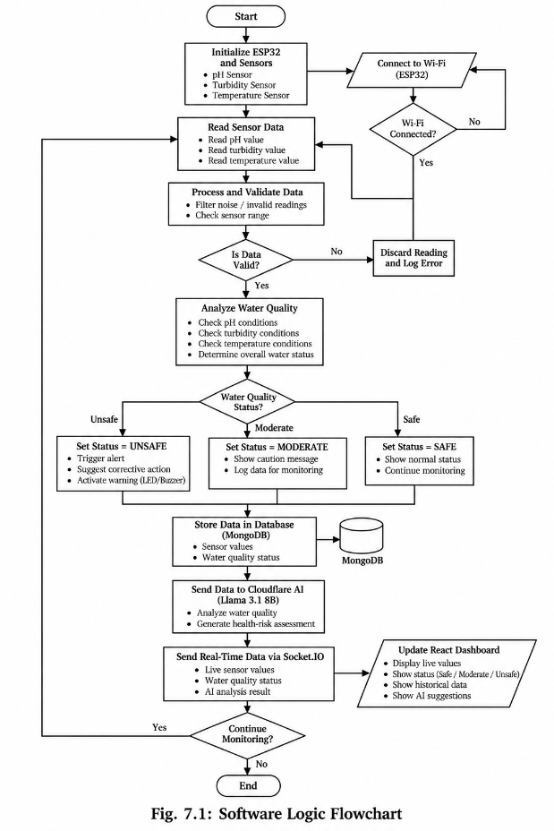
The overall software flow is:
This modular design allows individual services to be modified or extended without significantly affecting the other components.

7.2 Control Algorithm Flowchart
The Aqua AI control algorithm processes each incoming sensor observation and determines the corresponding water-quality condition.
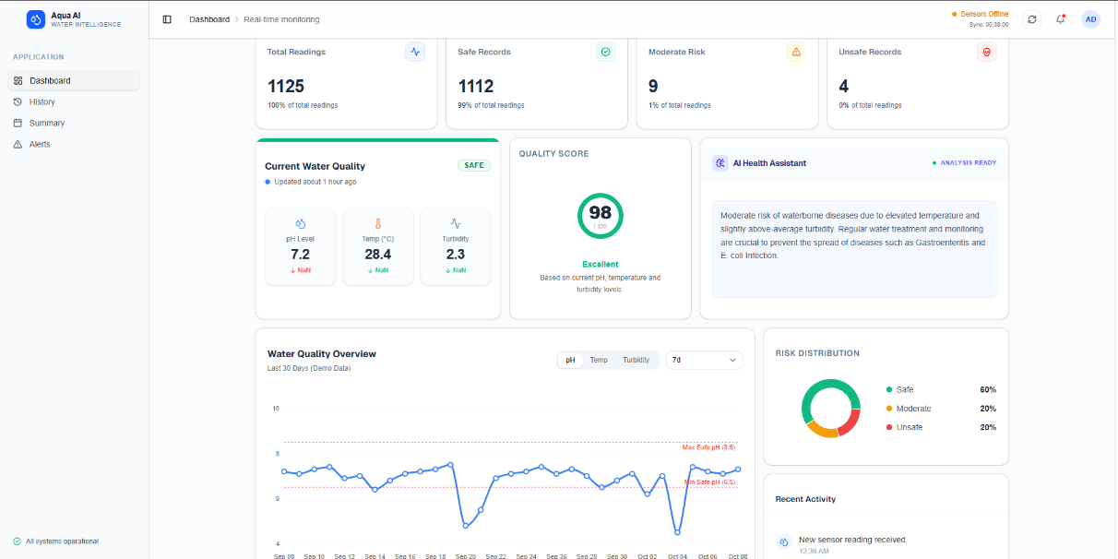
The classification begins when the backend receives a sensor observation. The pH, turbidity, and temperature values are examined against the predefined threshold conditions.
The general algorithm is:
The classification rules implemented in the system are:
- If pH < 6.5, the water is classified as Unsafe.
- If pH > 8.5, the water is classified as Unsafe.
- If turbidity > 10 NTU, the water is classified as Unsafe.
- If temperature > 35°C, the water is classified as Unsafe.
- If turbidity is greater than 5 NTU but does not meet an Unsafe condition, the water is classified as Moderate.
- If none of the above conditions are satisfied, the water is classified as Safe.
The algorithm is deterministic and provides an easily interpretable initial assessment of the monitored water condition.

7.2.1 Threshold Logic Implementation
The threshold-based classification is implemented through the calculateWaterQuality function in the water-quality service.
The logic can be represented as:
IF pH < 6.5 OR pH > 8.5
→ UNSAFE
ELSE IF turbidity > 10
→ UNSAFE

ELSE IF temperature > 35
→ UNSAFE

ELSE IF turbidity > 5
→ MODERATE

ELSE
→ SAFE
This approach provides consistency because the same conditions are applied to every incoming observation.
The threshold system also provides an explainable basis for the dashboard classification. Users can distinguish between a normal observation and one that exceeds a predefined environmental limit.

7.3 IoT Data Integration
The IoT data integration layer connects the sensor-data source with the Aqua AI backend.
In the current implementation, simulator.js acts as the data source. It generates sensor observations and sends them to the backend through a REST API. This simulates the behavior of an IoT device transmitting measurements over a network.
The data flow is:
Simulator / ESP32
│
│ HTTP POST
▼
Express.js API
│
▼
Data Processing
│
├──────────────► MongoDB
│
├──────────────► AI Service
│
└──────────────► Socket.IO
│
▼
React Dashboard
The simulator makes it possible to test the complete data pipeline without requiring physical sensors. It can generate different environmental conditions and allow the backend classification and dashboard behavior to be observed.
When physical ESP32 hardware is introduced, the simulator can be replaced by the ESP32 while retaining the same overall backend processing architecture.

7.4 AI Service Implementation
Aqua AI incorporates an AI service to provide an additional interpretation of the environmental observations.
The aiService.js module contains the predictDisease() functionality responsible for preparing the environmental information and communicating with the Cloudflare Workers AI service.
The system uses the Llama 3.1 8B Instruct model through Cloudflare Workers AI. Relevant sensor observations are included in the AI request, and the returned response is processed by the backend before being presented through the dashboard.
The AI processing flow is:
Sensor Data
│
▼
Backend Processing
│
▼
Create AI Prompt
│
▼
Cloudflare Workers AI
│
▼
Llama 3.1 8B Instruct
│
▼
Health-Risk Assessment
│
▼
Dashboard
The AI component is intended to provide an indicative risk assessment based on the available environmental information. It is not intended to replace laboratory water-quality testing or medical diagnosis.
The separation of the AI service from the main water-quality classification service also ensures that the deterministic water-quality classification can continue to operate independently of the AI response.

7.5 Real-Time Communication Using Socket.IO
Real-time communication is an important part of Aqua AI because users should be able to observe newly received sensor information without repeatedly refreshing the dashboard.
The backend uses Socket.IO to broadcast updated sensor observations to connected frontend clients.
When a new sensor observation is processed, the backend emits an event through the Socket.IO connection. The React frontend listens for these events and updates the relevant dashboard components.
The communication process is:

New Sensor Reading
│
▼
Backend Receives Data
│
▼
Process and Store Data
│
▼
Socket.IO Event
│
▼
Connected React Clients
│
▼
Dashboard Updated
This approach reduces the need for continuous polling from the frontend and provides a more responsive monitoring interface.

7.6 MongoDB Data Management
MongoDB is used as the primary database for storing sensor observations. The backend uses Mongoose to define and manage the sensor-data structure.
The SensorData.js model contains information associated with a sensor observation, including parameters such as:

- Device ID
- Location
- pH
- Turbidity
- Temperature
- Battery information
- Sensor observation metadata
The stored data provides a historical record of monitoring observations. This information can be used by the frontend to display previous measurements and identify changes in water-quality conditions over time.
The database architecture can be represented as:
Sensor / Simulator
│
▼
Express.js API
│
▼
Mongoose
│
▼
MongoDB
│
▼
Historical Sensor Data
The use of a centralized database also provides a foundation for future analytics, trend analysis, anomaly detection, and machine-learning model development.
Overall, the software and IoT implementation combines REST-based sensor ingestion, threshold-based water-quality classification, MongoDB persistence, AI-assisted analysis, Socket.IO real-time communication, and React visualization to form the core operational software of Aqua AI.
CHAPTER 8: TESTING METHODOLOGY AND RESULTS

8.1 Testing Methodology
Testing was performed to verify the functionality and reliability of the Aqua AI software pipeline. Since the current prototype uses a software-based sensor simulator instead of physical water-quality sensors, the testing focused on simulated sensor-data generation, backend processing, water-quality classification, database storage, AI integration, real-time communication, and dashboard visualization.
The testing process was divided into the following categories:
1. Functional Testing
Functional testing was used to verify whether individual system components performed their intended operations correctly. The simulator was tested for generating sensor observations, while the backend was tested for receiving and processing the submitted data.
2. Water Quality Classification Testing
Different combinations of pH, turbidity, and temperature values were supplied to the classification service. The resulting classification was compared with the predefined threshold rules.
3. API Testing
The REST API was tested by sending simulated sensor observations to the backend. The tests verified whether the backend correctly accepted, processed, and stored the submitted information.
4. Database Testing
MongoDB storage was tested to verify that incoming sensor observations were persisted correctly and that important fields such as device information, location, pH, turbidity, and temperature were retained.
5. AI Integration Testing
The AI service was tested to verify communication between the backend and Cloudflare Workers AI. The generated environmental information was passed to the AI service and the returned health-risk assessment was processed by the application.
6. Real-Time Communication Testing
Socket.IO communication was tested by generating new sensor observations and observing whether the connected dashboard received the updated information without requiring a manual page refresh.
7. Frontend Testing
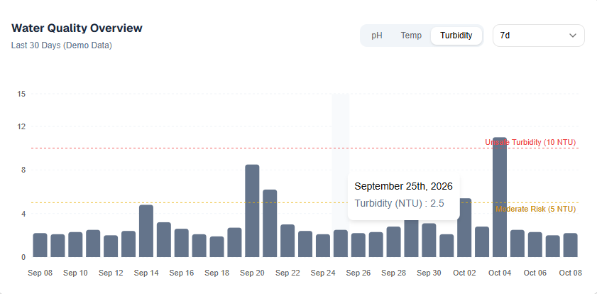
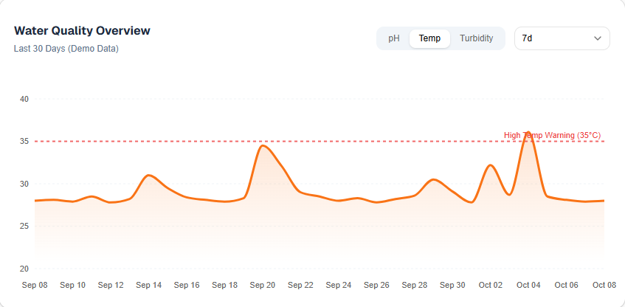
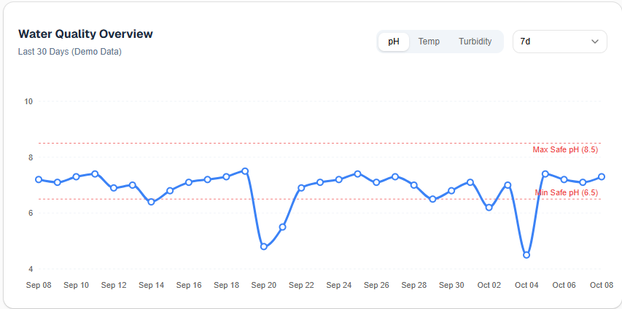
The React dashboard was tested to verify that sensor readings, water-quality classifications, historical information, and AI-generated results were displayed correct

8.2 Environmental Data Simulation Results
Since physical sensor hardware is not currently integrated into the prototype, representative environmental readings were generated using the simulator.
The simulator was used to generate different operating conditions, including normal and abnormal water-quality conditions. These observations were transmitted to the backend using HTTP requests.
Table 8.1: Representative Simulated Sensor Observations
Test Case | pH | Turbidity (NTU) | Temperature (°C) | Expected Status
Normal Condition | 7.2 | 2.5 | 26 | Safe
Moderate Turbidity | 7.1 | 7.0 | 27 | Moderate
High Turbidity | 7.0 | 12.0 | 28 | Unsafe
Low pH | 6.0 | 3.0 | 25 | Unsafe
High pH | 9.0 | 3.0 | 25 | Unsafe
High Temperature | 7.2 | 3.0 | 37 | Unsafe
The simulated results demonstrate that the backend can process different environmental conditions and apply the implemented classification rules.
These values represent simulated observations and should not be interpreted as measurements obtained from physical water samples.

8.3 Water Quality Classification Results
The water-quality classification service was tested using boundary and abnormal values for pH, turbidity, and temperature.
The implemented rules classify water as Unsafe when:
- pH is below 6.5.
- pH is above 8.5.
- Turbidity is greater than 10 NTU.
- Temperature is greater than 35°C.
If the water does not meet an Unsafe condition but turbidity is greater than 5 NTU, it is classified as Moderate.
All other observations are classified as Safe.
Table 8.2: Water Quality Classification Test Results
Test ID | Condition Tested | Expected Result | Observed Result | Status
TC01 | Normal pH, low turbidity | Safe | Safe | Pass
TC02 | Turbidity > 5 NTU | Moderate | Moderate | Pass
TC03 | Turbidity > 10 NTU | Unsafe | Unsafe | Pass
TC04 | pH < 6.5 | Unsafe | Unsafe | Pass
TC05 | pH > 8.5 | Unsafe | Unsafe | Pass
TC06 | Temperature > 35°C | Unsafe | Unsafe | Pass
The testing confirms that the implemented classification service responds according to the configured threshold conditions.

8.4 AI Analysis and System Integration Results
The AI component was tested by providing environmental observations to the Cloudflare Workers AI service. The backend prepares the relevant sensor information and sends it to the configured Llama 3.1 8B Instruct model.
The AI service successfully forms an additional interpretation layer over the environmental measurements. The returned response can be displayed through the monitoring dashboard alongside the sensor measurements and water-quality classification.
The AI integration process was tested as follows:
Simulated Sensor Data
│
▼
Express.js Backend
│
▼
Water Quality Classification
│
├───────────────► MongoDB
│
▼
Cloudflare Workers AI
│
▼
AI Health-Risk Assessment
│
▼
Dashboard
The AI result is treated as an indicative assessment rather than a medical diagnosis. The project does not claim that the AI output can independently confirm the presence of a waterborne disease.

8.5 Real-Time Dashboard and Communication Results
The real-time communication mechanism was tested by submitting new sensor observations through the simulator while the React dashboard was connected to the backend.
When a new observation was received, the backend processed and stored the data and then emitted the updated information through Socket.IO.
The frontend received the event and updated the dashboard without requiring a manual browser refresh.
Table 8.3: Real-Time System Testing
Test ID | Test Scenario | Expected Result | Result
RT01 | Submit new sensor reading | Backend receives data | Pass
RT02 | Store new observation | MongoDB record created | Pass
RT03 | Broadcast updated reading | Socket.IO event generated | Pass
RT04 | Receive event in frontend | Dashboard updates | Pass
RT05 | Submit abnormal reading | Updated Unsafe/Moderate status displayed | Pass

The testing demonstrates that the simulator, backend, database, Socket.IO communication, and React dashboard can operate together as an integrated software pipeline.
8.6 Test Summary
The testing performed on the current Aqua AI prototype confirms the operation of the major software components. The simulator successfully generates representative sensor observations, the backend processes incoming data, the water-quality service applies the configured classification rules, and MongoDB provides persistent storage.
The Cloudflare Workers AI integration provides an additional AI-assisted analysis layer, while Socket.IO enables real-time transmission of updated observations to the React dashboard.
However, the current results are based on simulated sensor data. Physical sensor accuracy, environmental calibration, long-term hardware reliability, and real-world water-quality performance have not yet been experimentally validated.
Therefore, the present testing establishes the functionality of the software and simulation prototype, while physical hardware testing and real-world dataset validation remain important areas for future development.

CHAPTER 9: CONCLUSION AND FUTURE SCOPE

9.1 Conclusion
Aqua AI was developed as a real-time, IoT-oriented water-quality monitoring and AI-assisted early-warning system. The primary objective of the project was to provide a platform capable of collecting environmental observations, processing water-quality parameters, storing monitoring data, and presenting meaningful information through a web-based dashboard.
The system focuses on three important water-quality parameters: pH, turbidity, and temperature. These parameters are processed using predefined threshold-based rules to classify the observed condition as Safe, Moderate, or Unsafe. This provides a simple and explainable mechanism for identifying potentially abnormal water conditions.
The project integrates a Node.js and Express.js backend, MongoDB database, React.js frontend, and Socket.IO real-time communication. The integration of these technologies allows sensor observations to move through the complete monitoring pipeline, from data generation and processing to storage and visualization.
An additional AI layer was implemented using Cloudflare Workers AI with the Llama 3.1 8B Instruct model. The AI service provides an indicative health-risk assessment based on the available environmental information. This feature extends the system beyond simple sensor-data visualization and provides an additional layer of automated interpretation.
The current prototype uses a software simulator to represent the IoT sensor layer. Testing with simulated observations demonstrated that the backend can receive sensor data, classify water-quality conditions, store observations in MongoDB, communicate with the AI service, and update the React dashboard through Socket.IO.
The project therefore demonstrates the feasibility of integrating IoT-oriented monitoring, automated water-quality classification, cloud database storage, AI-assisted analysis, and real-time web visualization into a unified platform.
However, the current results are based on simulated sensor data. Physical sensor accuracy, calibration, real-world environmental conditions, and long-term hardware reliability have not yet been experimentally validated. Consequently, the current implementation should be considered a software and simulation proof-of-concept rather than a fully validated physical water-quality monitoring device.

9.2 Future Scope
Physical ESP32 and Sensor Integration
The most important future enhancement is the integration of physical ESP32-based hardware with pH, turbidity, and temperature sensors. This would allow Aqua AI to collect actual water-quality measurements instead of simulated observations.
Additional Water Quality Sensors
The system can be extended with additional sensors such as dissolved oxygen, Total Dissolved Solids (TDS), electrical conductivity, water level, and other relevant environmental parameters. Monitoring additional parameters would provide a more comprehensive assessment of water conditions.
Custom Machine Learning Model
The current AI functionality relies on an external Cloudflare Workers AI service. In the future, a dedicated machine-learning model could be trained using a sufficiently large real-world water-quality dataset. Such a model could be evaluated specifically for water-quality classification, anomaly detection, and risk prediction.
Real-Time Alert and Notification System
Aqua AI can be extended with SMS, email, mobile push notifications, or other alert mechanisms. Users could receive immediate notifications when sensor readings exceed predefined safety thresholds.
Historical Trend and Predictive Analysis
Long-term sensor observations can be analyzed to identify seasonal patterns, recurring abnormalities, and changes in water quality. Predictive models could potentially forecast future water-quality conditions based on historical observations.
Multi-Location Monitoring
The system can be expanded to support multiple ESP32 monitoring nodes installed at different water sources. A centralized dashboard could display the status of multiple locations and allow users to compare environmental conditions across different areas.
Mobile Application
A dedicated Android or cross-platform mobile application could provide convenient access to sensor readings, alerts, historical data, and AI analysis. This would improve accessibility for users who primarily rely on smartphones.
Offline and Edge Processing
Future versions could implement basic processing directly on the ESP32 or an edge device. This could allow preliminary classification to continue even when internet connectivity is temporarily unavailable.
Real-World Dataset Development
A significant future requirement is the collection of a reliable dataset containing real sensor measurements and corresponding water-quality observations. Such a dataset would improve the evaluation of the system and provide a foundation for developing and validating custom machine-learning models.
Integration with Laboratory Testing
Future implementations could combine automated sensor monitoring with periodic laboratory testing. Laboratory results could be used as reference data to calibrate sensors, evaluate classification accuracy, and validate AI-based predictions.
Overall, these extensions can transform Aqua AI from its current software-based proof-of-concept into a complete physical IoT platform capable of continuous water-quality monitoring and intelligent early-warning support.

REFERENCES

[1] World Health Organization, Guidelines for Drinking-water Quality: Fourth Edition Incorporating the First, Second and Third Addenda, World Health Organization, Geneva, 2026.

[2] World Health Organization, Drinking-water, WHO Fact Sheet, 2023.

[3] World Health Organization, Guidelines for Drinking-water Quality: Small Water Supplies, World Health Organization, 2024.

[4] World Health Organization, Water Quality: Guidelines, Standards and Health — Assessment of Risk and Risk Management for Water-related Infectious Diseases, World Health Organization, 2001.

[5] World Health Organization, Top 10 Drinking-water and Sanitation Related Pathogens, World Health Organization, 2025.

[6] World Health Organization, Water Safety and Quality, WHO Water, Sanitation and Health Programme.

[7] World Health Organization, Guidelines for Drinking-water Quality: Microbial Aspects, World Health Organization.

[8] M. A. Hossain et al., “Advances in Machine Learning and IoT for Water Quality Monitoring: A Comprehensive Review,” Heliyon, 2024.

[9] “A Review of Machine Learning and Internet-of-Things on the Water Quality Assessment: Methods, Applications and Future Trends,” Results in Engineering, 2025.

[10] “Critical Review on Water Quality Analysis Using IoT and Machine Learning Models,” Environmental Technology & Innovation, 2024.

[11] United States Environmental Protection Agency, Water Quality Standards: Regulations and Resources, U.S. EPA.

[12] United States Environmental Protection Agency, Drinking Water Requirements for States and Public Water Systems, U.S. EPA.

APPENDIX A: MICROCONTROLLER SOURCE CODE
The following source code represents the microcontroller-side implementation proposed for the Aqua AI system. The ESP32 acts as the IoT data-acquisition unit and is responsible for collecting water-quality parameters and transmitting the observations to the backend server.
Note: In the current prototype, the hardware layer is represented by a software simulator. Therefore, the following code is provided as the intended ESP32 implementation for future physical sensor integration.
A.1 ESP32 Source Code
#include <WiFi.h>
#include <HTTPClient.h>
#include <ArduinoJson.h>

// ---------------- Wi-Fi Configuration ----------------
const char* WIFI_SSID = "YOUR_WIFI_NAME";
const char* WIFI_PASSWORD = "YOUR_WIFI_PASSWORD";

// Backend API endpoint
const char* SERVER_URL = "http://YOUR_SERVER_IP:5000/api/sensor";

// ---------------- Sensor Pins ----------------
#define PH_SENSOR_PIN 34
#define TURBIDITY_SENSOR_PIN 35
#define TEMPERATURE_SENSOR_PIN 32

// ---------------- Device Information ----------------
const char* DEVICE_ID = "AQUA_ESP32_01";
const char* LOCATION = "Community Water Source";

// ---------------- Timing ----------------
unsigned long previousMillis = 0;
const unsigned long interval = 5000;

// ------------------------------------------------------
// Connect ESP32 to Wi-Fi
// ------------------------------------------------------
void connectWiFi() {
Serial.print("Connecting to Wi-Fi");

WiFi.begin(WIFI_SSID, WIFI_PASSWORD);

while (WiFi.status() != WL_CONNECTED) {
delay(500);
Serial.print(".");
}

Serial.println();
Serial.println("Wi-Fi connected");
Serial.print("ESP32 IP Address: ");
Serial.println(WiFi.localIP());
}

// ------------------------------------------------------
// Read pH value
// ------------------------------------------------------
float readPH() {
int rawValue = analogRead(PH_SENSOR_PIN);

float voltage = (rawValue / 4095.0) * 3.3;

// Calibration-dependent conversion
float ph = 7.0 + ((2.5 - voltage) / 0.18);

return ph;
}

// ------------------------------------------------------
// Read turbidity
// ------------------------------------------------------
float readTurbidity() {
int rawValue = analogRead(TURBIDITY_SENSOR_PIN);

float voltage = (rawValue / 4095.0) * 3.3;

// Approximate conversion.
// Actual calibration should be performed using
// standard turbidity solutions.
float turbidity = (3.3 - voltage) * 10.0;

if (turbidity < 0) {
turbidity = 0;
}

return turbidity;
}

// ------------------------------------------------------
// Read temperature
// ------------------------------------------------------
float readTemperature() {
int rawValue = analogRead(TEMPERATURE_SENSOR_PIN);

float voltage = (rawValue / 4095.0) * 3.3;

// Example analog temperature conversion
float temperature = voltage * 10.0;

return temperature;
}

// ------------------------------------------------------
// Determine water quality
// ------------------------------------------------------
String calculateWaterQuality(
float ph,
float turbidity,
float temperature
) {

if (
ph < 6.5 ||
ph > 8.5 ||
turbidity > 10 ||
temperature > 35
) {
return "Unsafe";
}

if (turbidity > 5) {
return "Moderate";
}

return "Safe";
}

// ------------------------------------------------------
// Send sensor data to backend
// ------------------------------------------------------
void sendSensorData(
float ph,
float turbidity,
float temperature
) {

if (WiFi.status() != WL_CONNECTED) {
Serial.println("Wi-Fi disconnected");
return;
}

HTTPClient http;

http.begin(SERVER_URL);
http.addHeader("Content-Type", "application/json");

String waterQuality =
calculateWaterQuality(
ph,
turbidity,
temperature
);

StaticJsonDocument<512> json;

json["deviceId"] = DEVICE_ID;
json["location"] = LOCATION;
json["ph"] = ph;
json["turbidity"] = turbidity;
json["temperature"] = temperature;
json["waterQuality"] = waterQuality;
json["battery"] = 100;

String requestBody;

serializeJson(json, requestBody);

Serial.println("Sending sensor data:");
Serial.println(requestBody);

int responseCode =
http.POST(requestBody);

if (responseCode > 0) {

Serial.print("Server response: ");
Serial.println(responseCode);

String response =
http.getString();

Serial.println(response);

} else {

Serial.print("HTTP request failed: ");
Serial.println(
http.errorToString(responseCode)
);
}

http.end();
}

// ------------------------------------------------------
// Setup
// ------------------------------------------------------
void setup() {

Serial.begin(115200);

delay(1000);

Serial.println();
Serial.println("==============================");
Serial.println(" AQUA AI - ESP32");
Serial.println("==============================");

pinMode(PH_SENSOR_PIN, INPUT);
pinMode(TURBIDITY_SENSOR_PIN, INPUT);
pinMode(TEMPERATURE_SENSOR_PIN, INPUT);

connectWiFi();
}

// ------------------------------------------------------
// Main Loop
// ------------------------------------------------------
void loop() {

unsigned long currentMillis =
millis();

if (
currentMillis - previousMillis >=
interval
) {

previousMillis = currentMillis;

float ph =
readPH();

float turbidity =
readTurbidity();

float temperature =
readTemperature();

String status =
calculateWaterQuality(
ph,
turbidity,
temperature
);

Serial.println();
Serial.println("----- Sensor Reading -----");

Serial.print("pH: ");
Serial.println(ph);

Serial.print("Turbidity: ");
Serial.print(turbidity);
Serial.println(" NTU");

Serial.print("Temperature: ");
Serial.print(temperature);
Serial.println(" °C");

Serial.print("Water Quality: ");
Serial.println(status);

sendSensorData(
ph,
turbidity,
temperature
);
}
}
A.2 Source Code Description
The ESP32 program performs the following operations:
- Connects the microcontroller to a Wi-Fi network.
- Reads the pH, turbidity, and temperature sensors.
- Processes the sensor values.
- Classifies the water condition as Safe, Moderate, or Unsafe.
- Creates a JSON representation of the sensor observation.
- Sends the observation to the Aqua AI backend using an HTTP POST request.
- Prints sensor readings and server responses through the Serial Monitor.
- Repeats the process at a predefined time interval.
The threshold logic used in the microcontroller follows the same classification concept implemented by the backend. For the final physical implementation, the sensor-conversion formulas must be calibrated against the actual sensors and laboratory/reference measurements.

APPENDIX B: BILL OF MATERIALS (COST ESTIMATION)

The following bill of materials represents the estimated components required for the physical prototype of the Aqua AI water-quality monitoring system. The system is designed around an ESP32 microcontroller and water-quality sensors for collecting environmental parameters.

Table B.1: Bill of Materials
Sr. No. | Component | Quantity | Estimated Unit Cost (₹) | Estimated Cost (₹)
1 | ESP32 Development Board | 1 | 450 | 450
2 | pH Sensor Module | 1 | 650 | 650
3 | Turbidity Sensor | 1 | 350 | 350
4 | Temperature Sensor | 1 | 100 | 100
5 | Breadboard | 1 | 100 | 100
6 | Jumper Wires | 1 set | 100 | 100
7 | Connecting Wires | 1 set | 100 | 100
8 | 5V Power Supply / Adapter | 1 | 250 | 250
9 | USB Cable | 1 | 100 | 100
10 | Enclosure / Protective Case | 1 | 300 | 300
11 | Miscellaneous Components | 1 set | 300 | 300
 | Total Estimated Cost |  |  | ₹2,800

B.1 Cost Analysis
The estimated cost of the proposed prototype is approximately ₹2,800. The ESP32 serves as the central processing and communication unit, while the pH, turbidity, and temperature sensors provide the primary water-quality measurements.
The cost can vary depending on the sensor model, supplier, component quality, and enclosure design. The software components used in the prototype can significantly reduce development costs because the system uses open-source development frameworks and cloud-based services.

B.2 Future Hardware Expansion
The prototype can be expanded by adding additional sensors such as TDS, electrical conductivity, dissolved oxygen, water-level, and other environmental sensors. Additional communication and power-management components may also be required for a fully deployed multi-location monitoring system.
Note: The above values are estimated prototype costs and may vary from actual purchase prices. The current Aqua AI implementation uses simulated sensor data; therefore, the physical components listed above represent the proposed hardware implementation rather than components already validated in the current software prototype.

